**BillFlash Application Guide**

**AltaPoint**

**Versions 2014 – 2015  
Updated 11/24/2015**

**Table of Contents**

Section 1: BillFlash Services Overview 4

A. Services 4

* Mail 4
* Mail is a professional printed bills via the USPS First-Class Mail. Customize your Template with method changes, messages & color for each Sub-Account. You simplify payment processing with payment coupons and separate envelopes. 4
* eBill 4

B. User Interface 5

C. Integration with my Billing App 5

Section 2: Where to Work 6

A. Billers 6

When to add a User Account 6

* BillFlash.com 6
* My Billing Application 6

B. Payers 6

Set Up Your Payer's Bill Delivery Preferences 6

* MyProviderLink.com 7

Section 3: Overview of using AltaPoint with Bill Flash 8

* Available BillFlash Features 8
* AltaPoint and BillFlash 8

Section 4: Using AltaPoint 2014 - 2015 10

* Setup AltaPoint System Parameters. 10
* Upload Patient Statements to BillFlash. 11
* Processing Payments. 15
* Cancel / Refund 19
* Making Refunds 20
* ePay Payments 22

Notes for previous versions of AltaPoint 25

* Creating a statement file 27
* Advanced Customization Options: 29

# 

# Section 1: BillFlash Services Overview

## Services

**BillFlash Services are Integrated & Easy to Use**

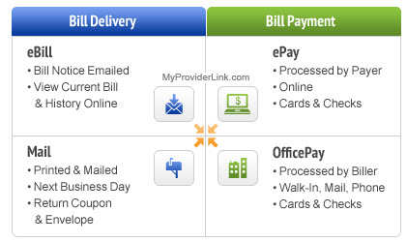

**Bill Delivery**

BillFlash provides a uniquely designed suite of Services which work together ensuring that Billers can easily Deliver Bills and Get Paid based on the distinct preferences which exist between each Biller and each Payer. It's all about having choices that work for both Billers and Payers.

### Mail

### Mail is a professional printed bills via the USPS First-Class Mail. Customize your Template with method changes, messages & color for each Sub-Account. You simplify payment processing with payment coupons and separate envelopes.

### eBill

**eBill is an electronic notification e-mailed to each Payer. This delivery setting is set for each time a Payer is entered from a File Upload into BillFlash. The eBill Notification will take the Payer to** [www.myproviderlink.com](http://www.myproviderlink.com) **to see their statement in full.**

## User Interface

The Bill Flash Services are Delivered through 3 user Interfaces:

**C:\Users\Support 2\Desktop\Screenshots\Help Learning Center\Screen Small.pngMy Billing App**

* **Used by: Billers**
* **Description: This is your current local billing application.**

**C:\Users\Support 2\Desktop\Screenshots\Help Learning Center\BillFlash Small.png BillFlash.com**

* **Used by: Billers**
* **Description: Use for the main BillFlash website.**

**C:\Users\Support 2\Desktop\Screenshots\Help Learning Center\MPL Small.png MyProviderLink.com**

* **Used by: Payers**
* **Description: Website for Payers to view & pay bills. Payers can also manage bill delivery preference.**

## Integration with my Billing App

**Integration between Bill Delivery & Payment Services**

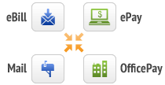

BillFlash provides a uniquely designed suite of Services which work together ensuring that Billers can easily Deliver Bills and Get Paid based on the distinct preferences which exist between each Biller and each Payer. It's all about having choices that work for both Billers and Payers.

**Top of Page**

**Integration of Services with My Billing Application**

BillFlash Services also integrate, at varying levels, with the local Billing Application used by the Biller. All Billers benefit from a minimum level of integration which allows them to use their Billing App to create files which are then uploaded and managed entirely through BillFlash.com. A growing number of Billing Application providers are increasing the level of BillFlash integration they support which enables Billers to complete many or all Billing & Payment actions directly within their Billing App rather than using BillFlash.com.

# Section 2: Where to Work

## Billers

#### When to add a User Account

* When you want to establish a unique username and password for different users.
* When you want to control access to restricted site pages by user.

### BillFlash.com

On BillFlash, when you enroll your account you will be asked to create the first Admin & then any number of limited users that you would like to have access to specific areas of the website.

### My Billing Application

Within your Billing Application, you will have Usernames & Passwords for your Login sessions that will be essential for use of your application. Within this guide, versions of this software may have the integration with your BillFlash Administrative account. Follow this guide to the Version sections for more information.

## Payers

# Set Up Your Payer's Bill Delivery Preferences

Specify each Payer's bill delivery preferences to: eBill, Mail, or Both.

\\SERVER\Data\HR\Team\Ryan\Screenshots\eBill Mail.jpg

**Set-Up Your Payer's Before You Upload Files**

* Set your default delivery preference for all current and new Payers at Settings.
* Pre-populate My Payers by uploading a file which contains all of your current Payers.
* Review My Payers and, as needed, Edit any Payers that are different than your account default.

### MyProviderLink.com

**Steps for Payers to Create their MyProviderLink.com Account**



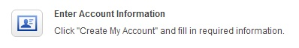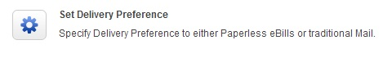

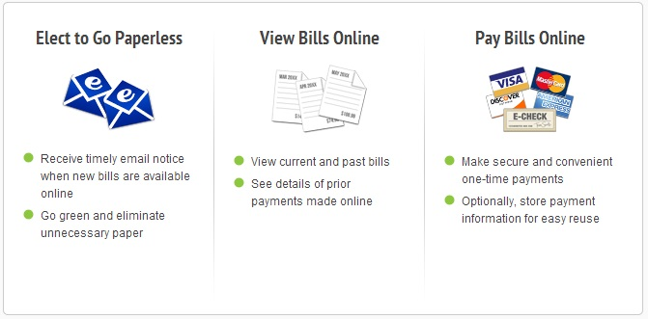

# Section 3: Overview of using AltaPoint with Bill Flash

### Available BillFlash Features

|  |  |  |
| --- | --- | --- |
| Using My Billing App Summary | |  |
| Billers | **Actions** | |
| Delivery | **Create** bills. **Upload** files to BillFlash. **Review** files. Change **Delivery Method** (ex., Mail to eBill). **Approve** files to deliver. **View** sent Documents. Manage **Reports**. | |
| * Mail | File level controls: Change **Color**. Edit **Messages**. | |
| * eBill | File level controls: Change e-mail or set for both. | |
| Payment | **Initiate, Cancel**, and **Refund** payments. Adjust **Balance**. **Find** payments. Manage **Reports**. | |
| * ePay | Having your Payers create an account on MyProviderLink.com & Pay their Bills. | |
| * OfficePay | Processing your Payers using Get Paid for Credit Card, Checks & Cash. Managing your Reports. | |
| Payers | **Actions** | |
| MyProviderLink.com | **Enroll** Payers in eBill & ePay. | |
| * eBill | Receive e-mail **eBill** notification, Create **Account** on MyProviderLink.com, View **Bills** online. | |
| * ePay | Pay **Bills** on MyProviderLink.com, Change **Delivery** **Method**, & save payment **Service Provider** for future Bills. | |

In this summary the place where billers work is color coded.   
**Red** – is done in AltaPoint. **Blue** - is done in BillFlash. **Purple** can be done in either AltaPoint or BillFlash.

### AltaPoint and BillFlash

AltaPoint is integrated with BillFlash for bill delivery and Office Pay payments. This integration allows AltaPoint to cooperate with BillFlash to send bills and get payments.

Let’s look at the workflow for getting paid.

Delivering Bills

The biller uses AltaPoint to send a statement file to BillFlash which sends individual bills to payers. These bills may be either mailed or sent as an eBill. Mailed bills are the usual paper bills. For privacy reasons, an eBill contain a link the payers account on MyProviderLink.com where they can login to see the bill and review past bills.

Paying Bills

The payer has several ways to pay the bill:

* Mail a check to the provider’s office.
* Walk into the office with a payment – cash, check or Credit Card.
* Phone the office and authorize a credit card payment.

These 3 choices directly involve the provider office which now uses AltaPoint and BillFlash (for non-cash payments) to process the payment using the Office Pay process. Since this is done in the office, both AltaPoint and BillFlash know about the payment.

* A payers makes an ePayment using their MyProviderLink.com account. The payer can use either a check or Credit Card. MyProviderLink.com works with BillFlash to process the payment.

BillFlash knows about the payment, but since this does not involve the office, AltaPoint does not.   
In AltaPoint the biller queries BillFlash to get the payment details and record them.

# Section 4: Using AltaPoint 2014 - 2015

### Setup AltaPoint System Parameters.

AltaPoint stores the username and password for your BillFlash account. This makes logging in to BillFlash automatic when switching between AltaPoint and BillFlash.

To setup your BillFlash username and password select File 1 then Online Services 2.   
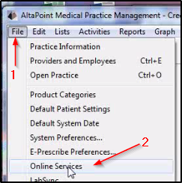

The Practice information window will open  
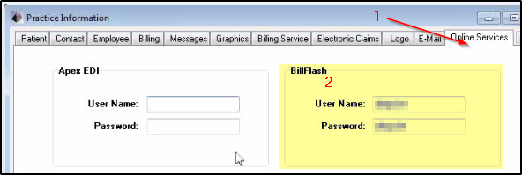

Under the Online services tab 1 enter your BillFlash User Name and Password.

### Upload Patient Statements to BillFlash.

To send bills to patients, a statement file is uploaded to BillFlash.   
To do this, from the Activities tab choose Billing and Collections then Print Statements – Not BillFlash.   
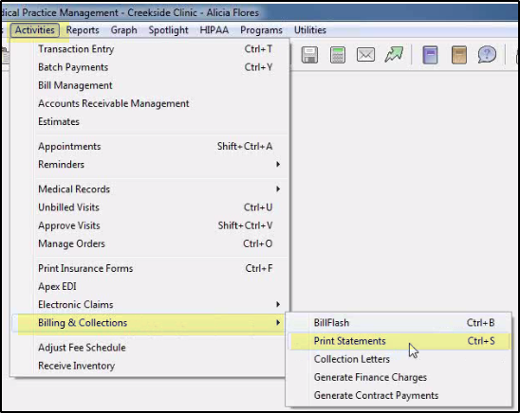

Then the Print Statements window opens. The Statement Form is typically BFSTANDARD.   
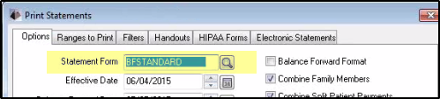

To see other report choices, click the search button by the Statement Form.   
There are just 2 that are for BillFlash.   
BillFlash Standard Statement is used for most billings done with BillFlash.   
BillFlash Copay Statement shows only copays.

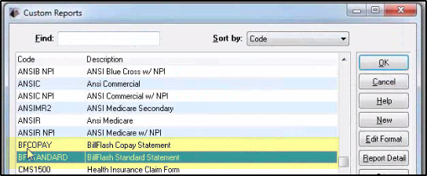

Fill the rest of the window, including any other tabs, in the way that is usual for your billing practice.   
Then click Print.  
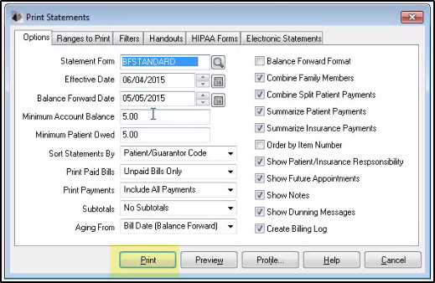

In the Electronic File Creation window the File Name will be C:\BILLFLASH\BILLFLASH_STATEMENT.TXT  
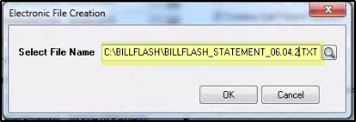

If you click OK then the file will be overwritten. We suggest adding a date to better describe the file, but keep the .TXT on the end.

If the file name is not changed and a previous save exists, you will see this message  
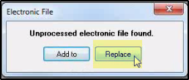

Replace is the choice that makes sense – Add to combines this billing file with whatever previously exists, which may not be sensible.

Confirm submitting to BillFlash.  
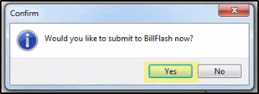

After a brief wait, AltaPoint opens a window that is logged into your BillFlash account for Review, Approve or Reject.  
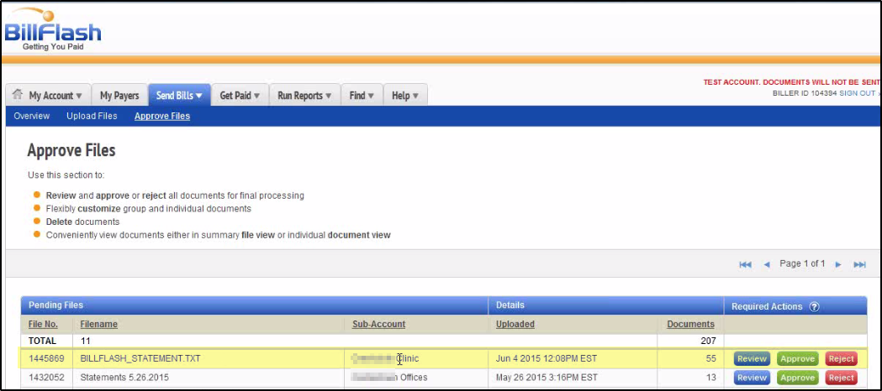

Information about the uploaded file is shown – Filename (will be the same as when it was saved), Sub Account, the upload date and the number of documents (bills).

Using the standard BillFlash process you can review, approve or reject this file.

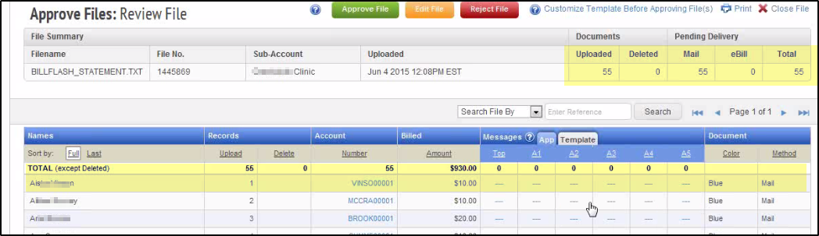

You can view an individual bill by Clicking on an Account  
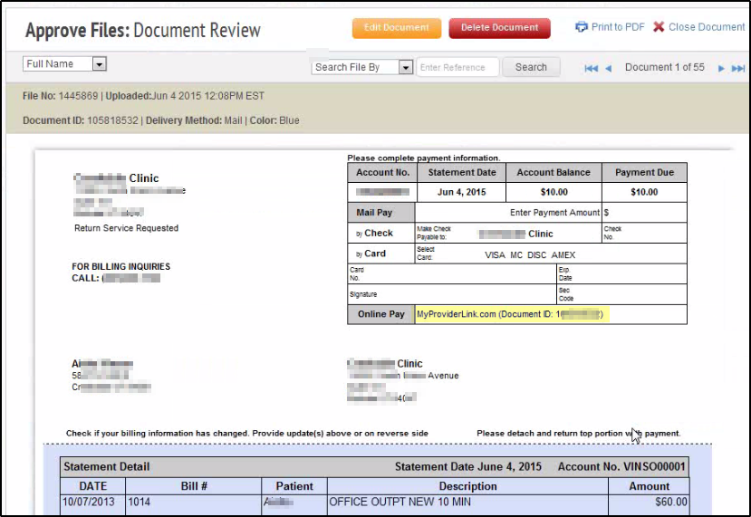

The file can be approved or Rejected

When the processing in complete close the BillFlash window. This takes you back to AltaPoint where the Print Statement window is now closed.

Let’s think about what information is known and where.

BillFlash knows if the received file is valid and which of the bills were approved and sent - also how they were sent – mail or eBill.

AltaPoint only knows that the file was sent.

### Processing Payments.

When the payer receives a bill it may be paid in several ways – mail a check to the office, call the office with a credit card payment or use MyProviderLink.com to make a payment.

For a payment made through the office it may be recorded in AltaPoint and processed using BillFlash.

To initiate a payment from the Activities menu select Billing & Collection then BillFlash.  
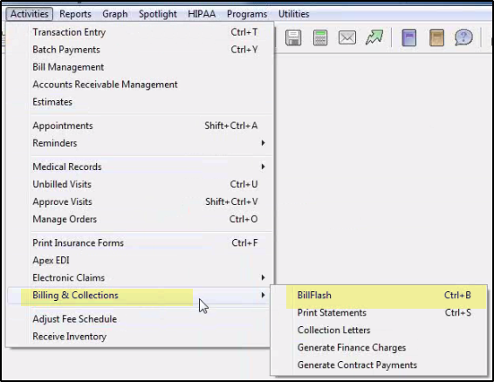

In the BillFlash window, statements tab there are 4 buttons that can take you to corresponding BillFlash pages. None of these send any information they just get you there. For example Sign In opens a page where you can sign in. What we want is the Billing tab  
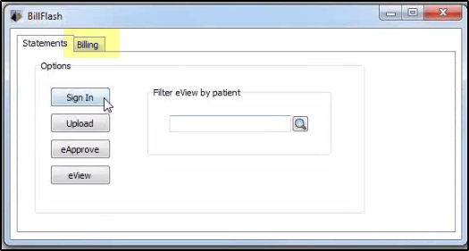

Here the left side 1 contains the address of the clinic which is used to identify the sub-account of the biller. On the right 2 fill in the patient information and add an Amount and Payment Type  
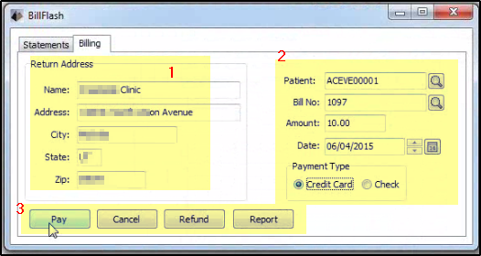

Note that of the 4 buttons Pay is the only one that sends any information to BillFlash. The other 3 only get to a BillFlash page but no data is sent.

Click Pay 3 to open the BillFlash Office Pay page.

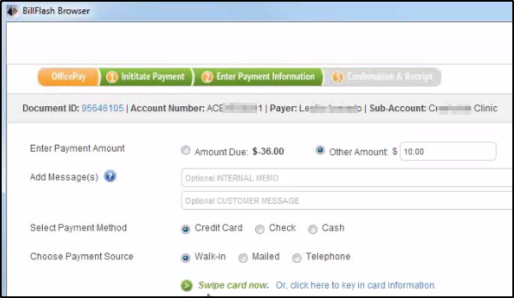

The information from AltaPoint is filled in. Edit as appropriate and choose the Payment Method and Source. Finish the transaction in the usual way – Swipe your card or manually enter check information.

The approval page shows details about the payment  
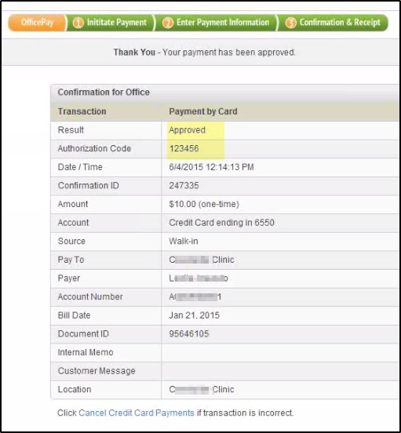

Otionaly print or email a receipt.  
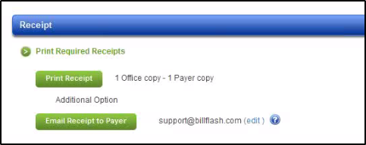

Close the page.   
Back in the AltaPoint BillFlash window the Patient fields now blank.  
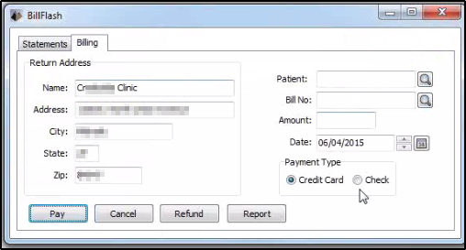

This indicates that the payment has been recorded in AltaPoint. (If you check the Patient File Ledger the payment is shown there.)

### Cancel / Refund

In the BillFlash window, when you fill in patient information, the Cancel and Refund buttons become enabled. Normally Cancel is expected to cancel the current process, however Cancel just opens BillFlash at a page where you can search for a payment to cancel. None of the information just entered in Lytec is sent to BillFlash. You could have directly opened the BillFlash cancel payment page and followed the usual steps to cancel a payment.

Either getting to BillFlash this way or by directly logging in, here is the process to cancel a Credit Card payment.

In BillFlash select Cancel Credit Card Payments  
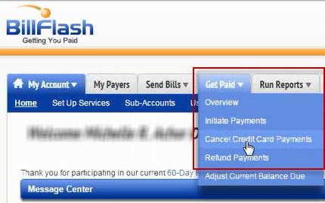

This allows cancelation of same day credit card charges.  
Enter the Confirmation ID or if you don’t have that, click ‘Don’t have Confirmation ID’ to search by account number or name.   
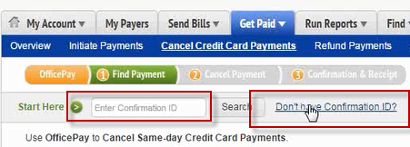

Search can find accounts, names, dates … It looks for an exact match. It is often easiest to search for the first or last name.

After cancelling a payment will need to manually update the patient account in AltaPoint to reflect this cancelation.

### Making Refunds

Refunds are used when a cancelation is not possible   
this includes Cash, Checks and Credit card transactions that are too old for a cancelation. (Not the same date.)

These are handled in a way similar to a cancelation.

* Starting with Refund Payments in BillFlash.  
  Enter the confirmation ID or search for the payment to be refunded.  
  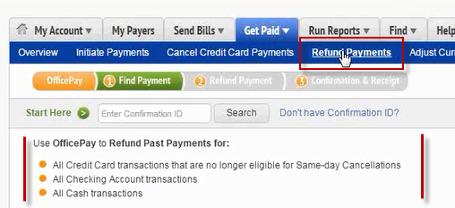
* choose the Refund Amount – Amount Paid or Other Amount to refund just a portion,   
  enter an amount in Other Amount  
  Optionally enter Internal Memo or Customer Message  
  click Process Refund

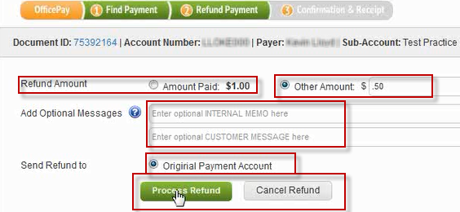

* Verify that the details are correct paying particular attention to the Amount, Payer and Account number.  
  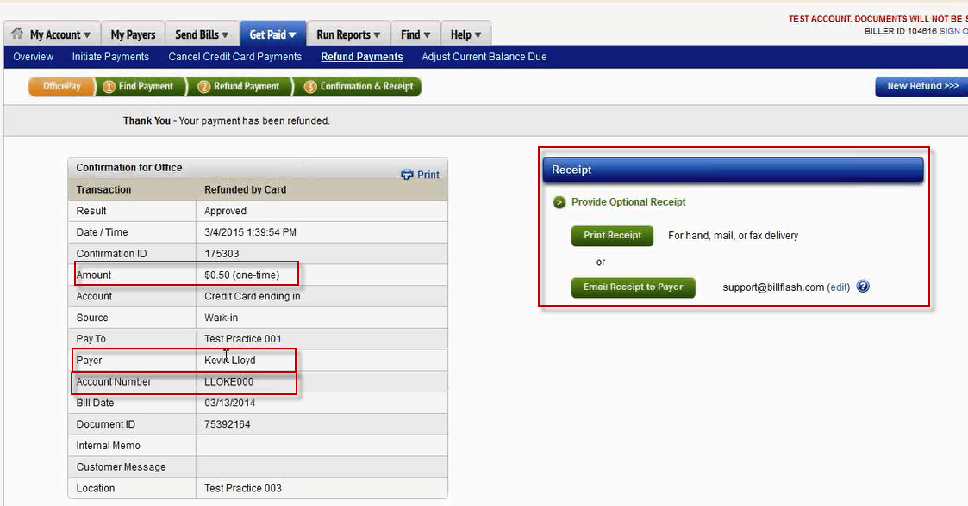  
  A receipt may be printed or emailed.   
  If and email address had been previously entered in BillFlash for this payee it will appear, otherwise click edit to enter one.  
  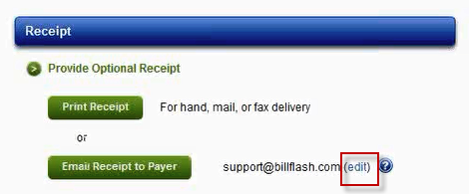

When the refund is complete you will need to manually update the patient account in AltaPoint to reflect the refund.

### ePay Payments

For a payment processed by the payer at MyProviderLink.com the office does not know about it. You can find about that have been made by getting a report in BillFlash. From that report you can update patient records in AltaPoint.

From the Activities tab in AltaPoint, choose Billing & Collection>BillFlash then the Billing tab in the BillFlash window. Click Report.  
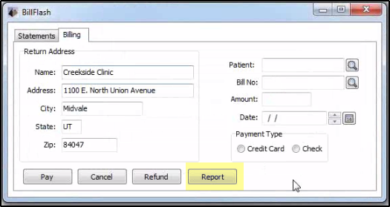

BillFlash will open the Standard Reports / Payment Reports page. Choose the Date Range of interest,  
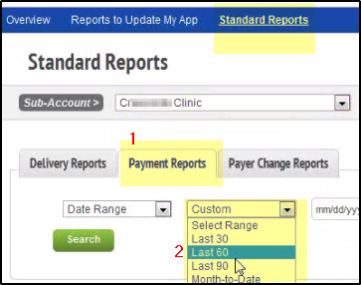

This report of payments made through BillFlash has payments made by the biller and by the payer. Use this to update and reconcile payments in AltaPoint.  
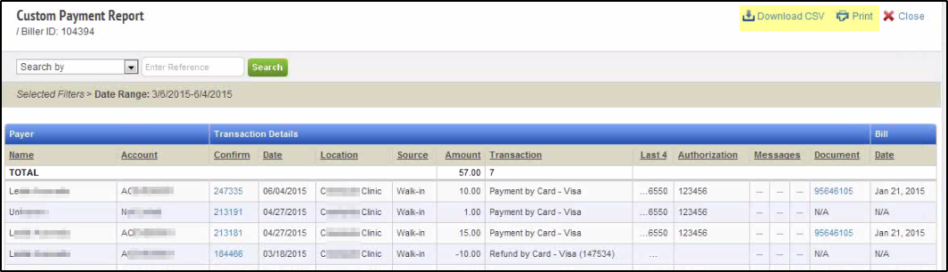

# Notes for previous versions of AltaPoint

1. **Open the AltaPoint report by double clicking on the link for the desired report.**
2. **Right click the mouse and select “All” to highlight everything in the report. Right click again and select “Copy”. This copies the code into the Windows clipboard.**
3. **Open the AltaPoint application.**
4. **Select the “Reports” tab from the top menu.**
5. **Select the “Create Custom Reports” (Version 6 is Design Statements and Insurance Forms) option.**
6. **Highlight the “ESTATEMENT” report from the list by clicking once on the report.**
7. **Click “Copy” on the right side of the screen.**

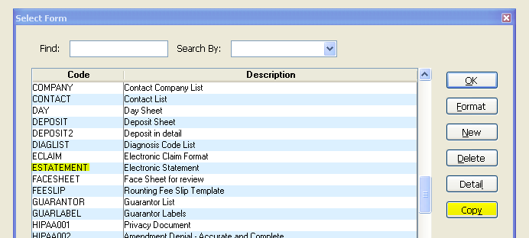

1. **This brings up a window asking for “New Report Code”, enter “BillFlash” and “New Report Name”, and enter “BillFlash Statements.”**

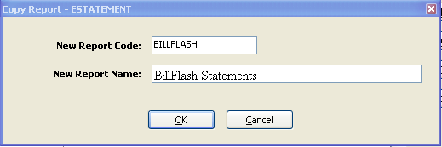

1. **Click “OK.”**
2. **A new report has now been created.**
3. **Now copy the items in the clipboard (from step 2) over the current contents of the report. To do this:**
   1. Single click on the new “BillFlash” report to high light it.
   2. Click the “Detail” button (Version 6 is “Report Details”).
   3. Highlight all the report code, the best way to do this is to right click the mouse and click “Select All”, press delete to eliminate all the current code.
   4. To past the new report code in, click the right mouse button and select “Paste”. This will past the code from step 2 into this report.
   5. Click the “OK” button (Caution: Do not click the “Form” button, this may lock up the AltaPoint application).
4. **The report has been installed.**

### Creating a statement file

1. **Create a statement file using the installed BillFlash Report. Run the report through the “Activities” dropdown by selecting the “Print Statements” option.**

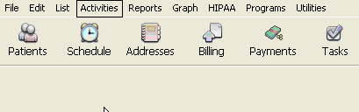

* 1. In the “Statement Form” field, select the BillFlash report desired.

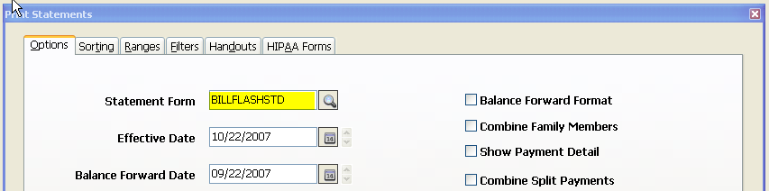

* 1. Select the various desired AltaPoint options.
  2. Click “Print.”
  3. Save the statement file with the desired file name.
     1. If you want the path automated, we suggest you modify the path in the BillFlash report.
     2. If you are given the option to “Add To” or “Replace” select Replace.

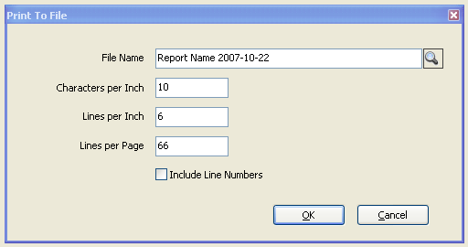

1. **The file has now been created in the designated folder and is ready to upload through BillFlash.com.**

***Important Caution:*** The AltaPoint feature “Pay Item” causes problems when generating statements if the “Summarize” box is checked. If Pay Item is a method used to enter payments, make sure to do the following:

* Payments entered using Pay Item use the same Item Number as the transaction the payment is applied to.
* When Print Statement is selected in AltaPoint, there is a check box on the right labeled ‘Summarize Patient Payment’ and ‘Summarize Insurance Payment’. If these are checked, the payments will not show up as individual line items in the statements, but will instead be shown as the last payment received.

1. **Upload the statement file to BillFlash for processing.**

* The BillFlash file will be created in the “c:/BillFlash” folder ready for uploading through BillFlash.com.
* To upload the file created, follow the upload instructions in BillFlash under Support/ BillFlash User Guide.

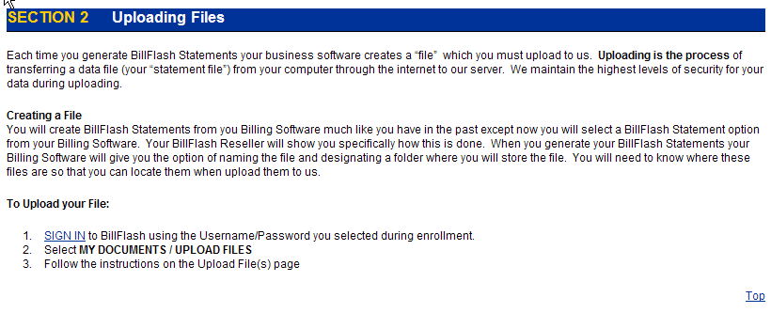

### Advanced Customization Options:

1. **Please contact your BillFlash Reseller for Customization Options.**